Diseño mecánico - FACSAM

# ENSAMBLADO - Partes de la carcasa

|  |  |  |
| --- | --- | --- |
| **ITEM NO.** | **PART NUMBER** | **Folded / QTY.** |
| 1 | Foldable Cubesat Z+ | 1 |
| 2 | Foldable Cubesat Side Panels | 2 |
| 3 | Foldable Cubesat Top Side Panel | 1 |
| 4 | Foldable Cubesat Top Panels | 1 |
| 5 | Foldable Cubesat Front Panel | 1 |
| 6 | 4-40 91253102 | 5 |

|  |  |
| --- | --- |
| **Z+** | **Side Panels** |
|  |  |
| **Top Side Panel** | **Top Panels** |
|  |  |
| **Front Panel** | **4-40 91253102** |
|  |  |

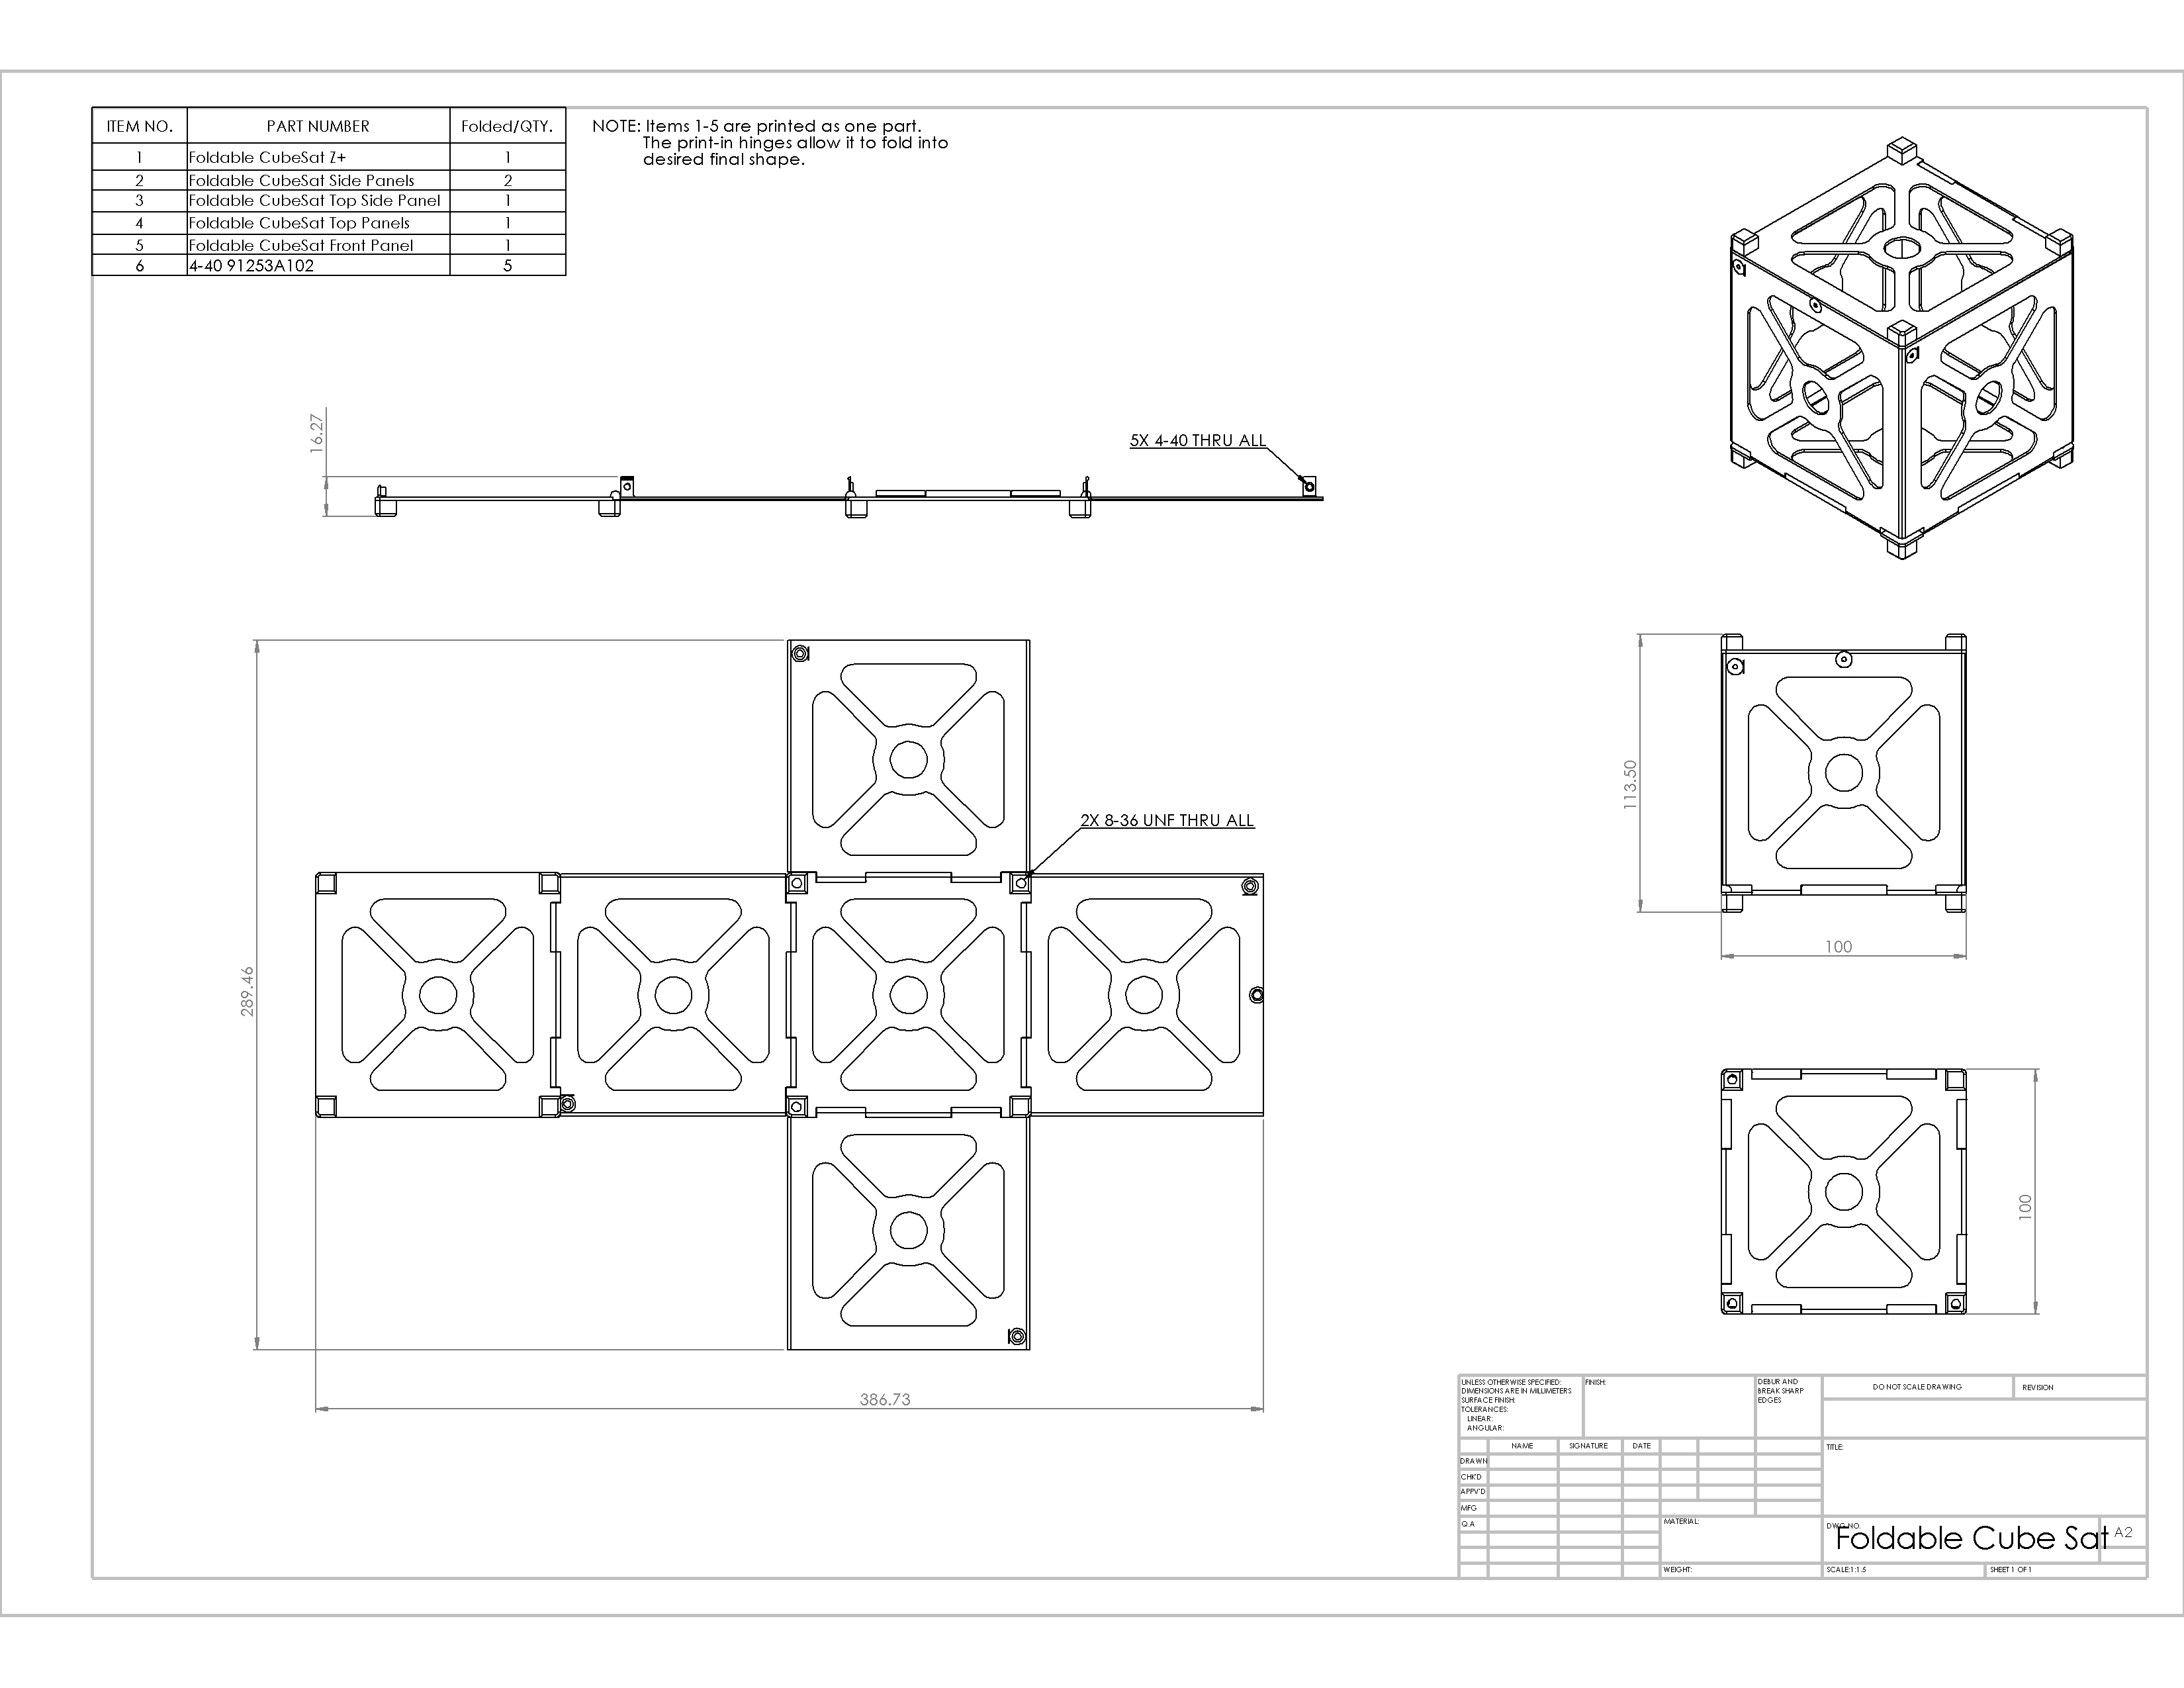

# Totalmente abierto

|  |  |  |  |
| --- | --- | --- | --- |
| **1** | Foldable Cubesat Z+ | **4** | Foldable Cubesat Top Panels |
| **2** | Foldable Cubesat Side Panels | **5** | Foldable Cubesat Front Panel |
| **3** | Foldable Cubesat Top Side Panel |

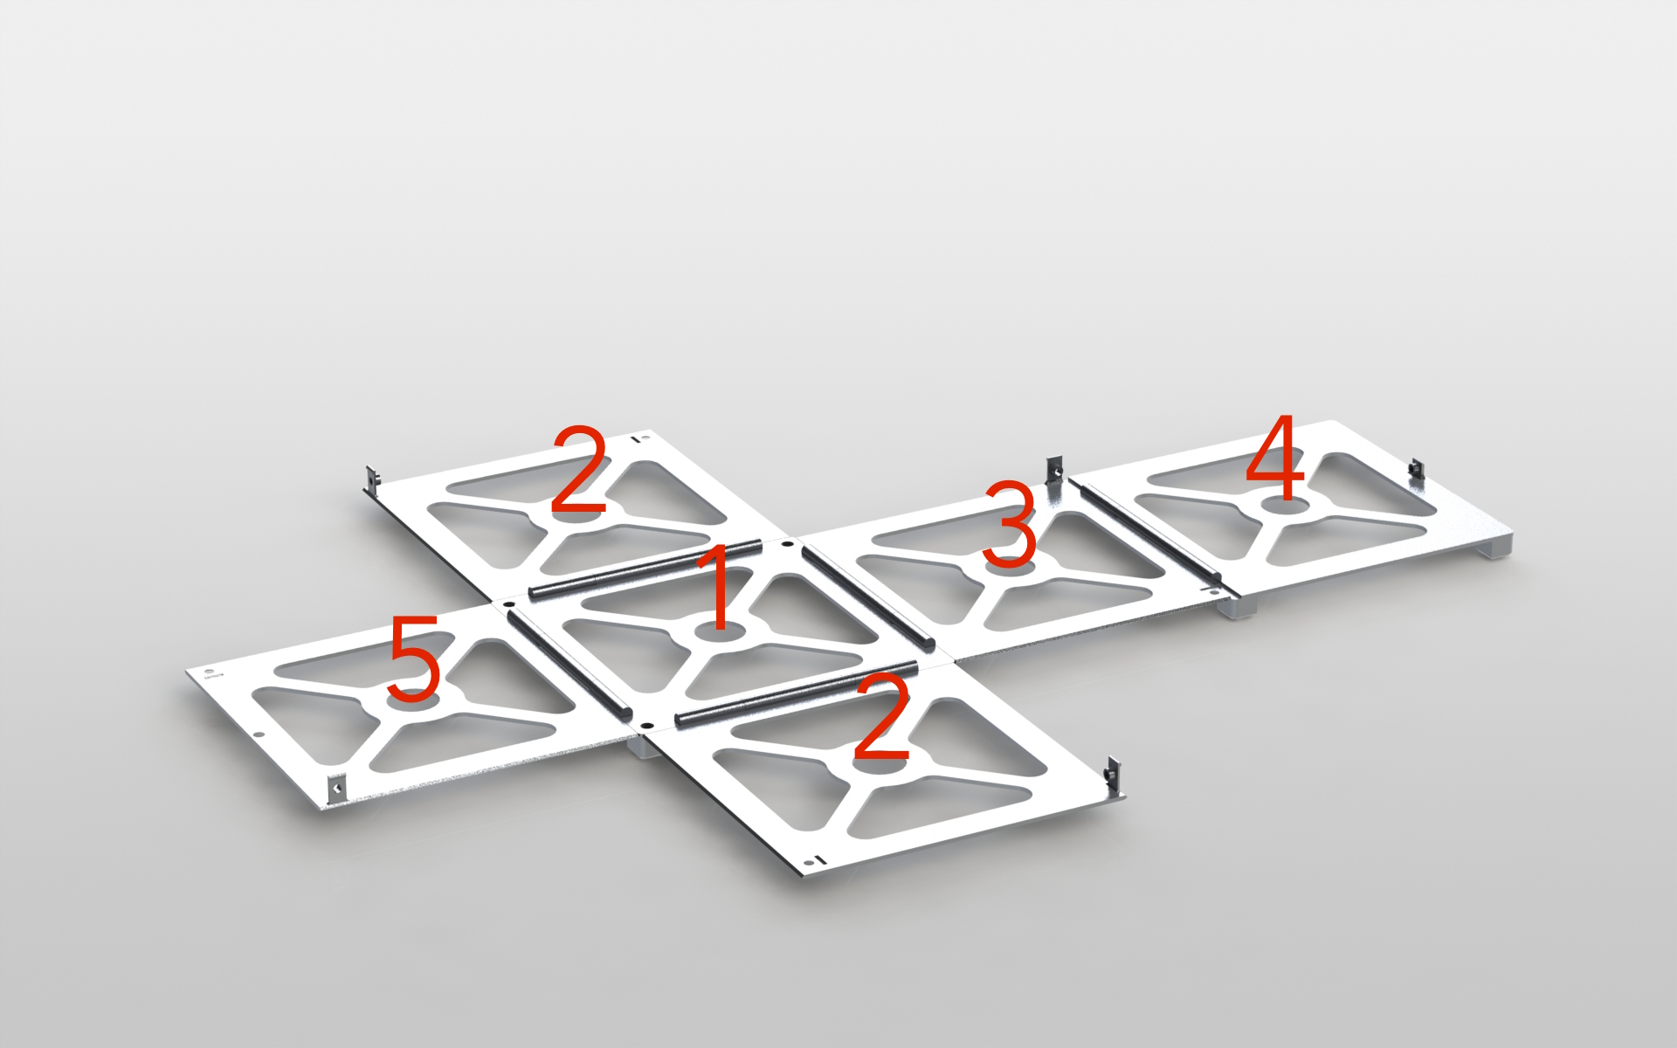

# Parcialmente abierto

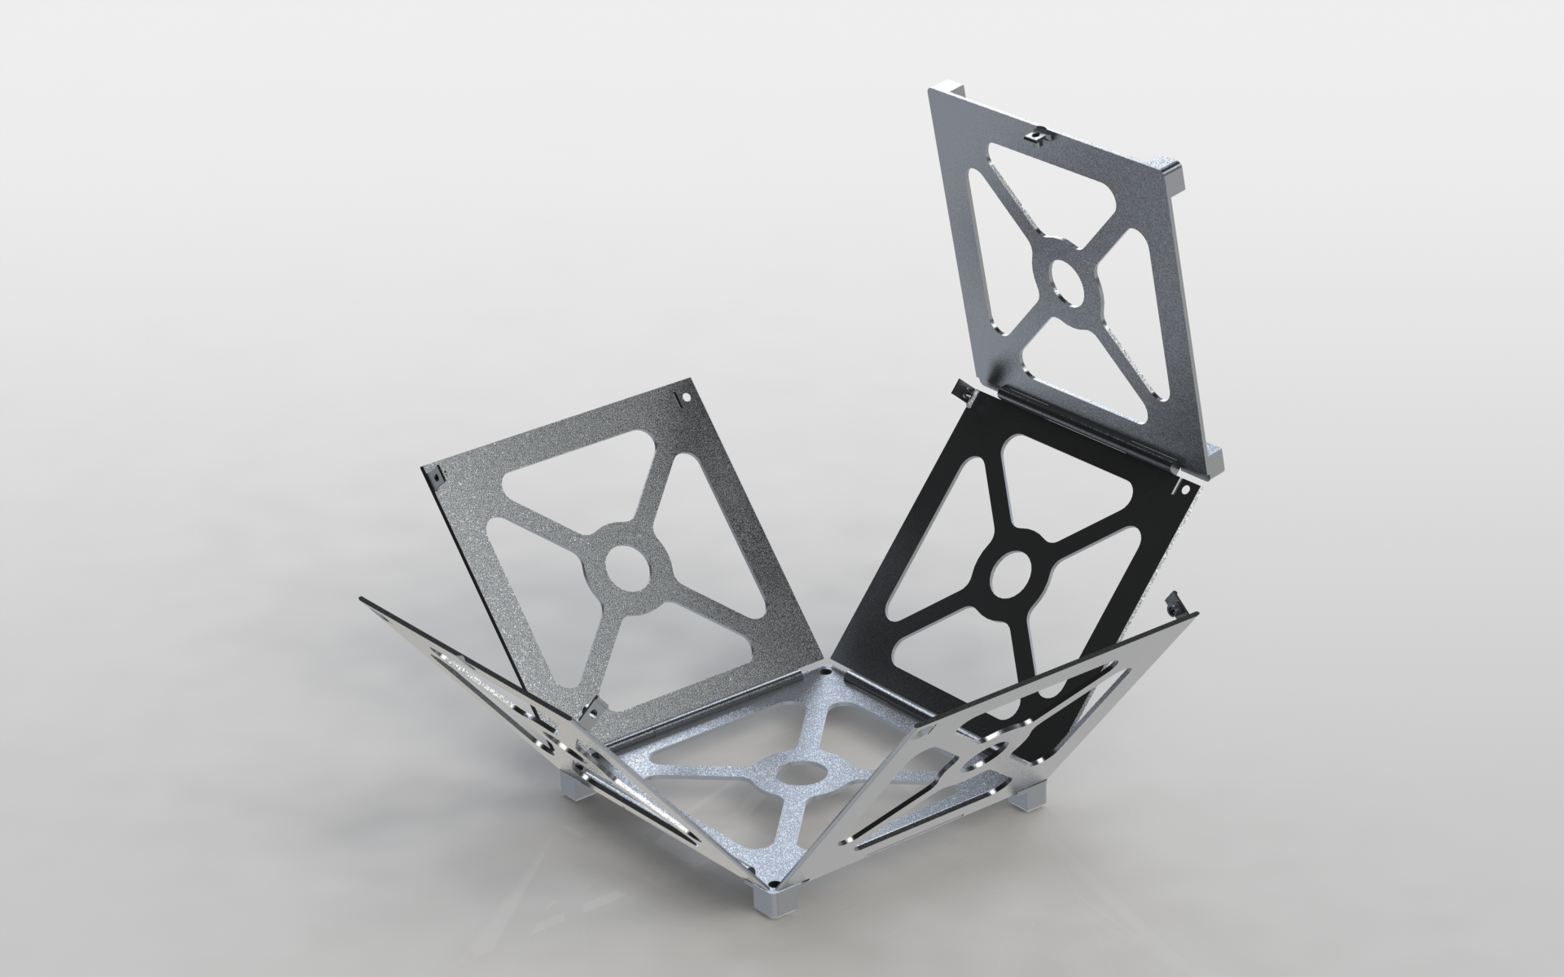

# Totalmente Cerrado

